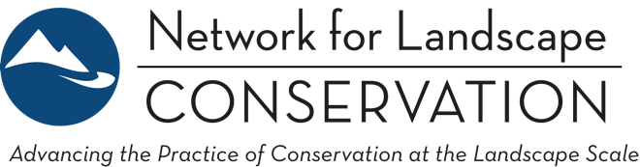

LANDSCAPE CONSERVATION CATALYST FUND
Request for Proposals: 2020 Funding Round
February 3, 2020

- OVERVIEW

The Network for Landscape Conservation (Network) is pleased to release this Request for Proposals (RFP) for the 2020 funding round of the Landscape Conservation Catalyst Fund. The purpose of the Landscape Conservation Catalyst Fund is to accelerate the pace of conservation at scale across the United States through targeted support of collaborative Landscape Conservation. This Fund is made possible through the generous support of the Doris Duke Charitable Foundation and the William and Flora Hewlett Foundation.

The Catalyst Fund will provide approximately $335,000 in funding through competitive grants in 2020. Partnerships may request a one- or two-year grant of $10,000 to $25,000.

The Catalyst Fund is open to any Landscape Conservation Partnership in the United States. All interested applicants should review this RFP—as well as the supplemental Applicant Guidance Document—to determine their fit with the Fund and how to submit a strong proposal. A portion of the Fund is reserved specifically for Indigenous-led Partnerships that work to advance Indigenous landscape conservation priorities. Specific guidance for Indigenous-led Partnerships is noted in appropriate locations throughout this RFP, and is also summarized in Section 2 of the Applicant Guidance Document.

Key dates in the 2020 funding round are as follows:

2020 Activity | Date
RFP release | Monday, February 3rd
Pre-proposals due | Friday, March 13th
Pre-proposal decisions | Friday, May 1st
Full proposals due | Friday, May 29th
Catalyst grants announced | On or before Tuesday, September 1st

- PURPOSE OF THE FUND
The purpose of the Landscape Conservation Catalyst Fund is to accelerate the pace of conservation at scale across the United States through targeted support of collaborative Landscape Conservation. The Catalyst Fund specifically supports key collaborative processes and activities to build critical capacity and forward conservation momentum in Landscape Conservation Partnerships.

The Catalyst Fund was established in recognition that:
- Working at the landscape scale—the scale nature functions—is the only effective way to tackle pressing challenges such as climate change, habitat loss, and landscape fragmentation;
- Extensive and enduring collaboration is essential to achieving successful conservation across whole landscapes; and
- It takes dedicated time and resources to build and sustain such collaboration, and this is not possible without directing sufficient funding specifically for this purpose—yet funding to directly support collaboration is scarce and difficult to acquire.

- FUND PRIORITIES

PRIORITY: LANDSCAPE CONSERVATION PARTNERSHIPS
The Catalyst Fund directs funding to Landscape Conservation Partnerships, defined, for the purposes of this RFP, as:

- Place-based: The Partnership has defined a geographically explicit area of focus—a landscape—that is sufficiently large in scale to span political boundaries and encompass a diversity of landowner types, conservation issues, jurisdictions, and stakeholder interests.
- Focused on a Shared, Long-term Conservation Vision: The Partnership has articulated a long-term, holistic vision—encompassing people and nature—for the ecological health and resilience of the defined landscape, with clearly identified conservation goals and outcomes.
- Collaboratively Governed: Although one organization may play a lead convening or coordination role in the Partnership, a formal or informal governance structure or decision-making process fosters collaborative leadership and ensures participatory engagement of a diversity of partners.
- Inclusive: The Partnership emphasizes inclusive outreach and dialogue with a breadth of stakeholders on the landscape to build a holistic vision (and action) informed by multiple interests and perspectives.
- Informed: The Partnership is committed to building the shared foundation of knowledge necessary to achieve its goals, and is rigorous in utilizing ecological, cultural, traditional, and/or social information to inform its work.

See the Applicant Guidance Document for more on the Landscape Conservation Partnership definition, and to determine if your initiative is an appropriate fit.

PRIORITY: PARTNERSHIPS IN THE “BUILDING” STAGE
The Catalyst Fund prioritizes Partnerships that are at the strategic point in Partnership development of navigating the transition from collective vision to collective action. We call this, for the purposes of this RFP, the “Building” Stage. See Figure 1 to understand the Building Stage of Partnership development.

Proposals from “Conserving” Stage Partnerships may be considered in exceptional situations where the outcomes of the grant period will be of significant value to the broader landscape conservation field. Proposals from Partnerships in the “Starting” Stage will not be considered at this time. Applicants interested in applying on behalf of a Conserving Stage Partnership should contact the Catalyst Fund Manager prior to applying.

See the Applicant Guidance Document for greater detail on the stages of Partnership development and the Fund’s priorities around the Building Stage.

FIGURE 1: Generalized Stages of Partnership Development
The below figure depicts the common progression of development for successful Landscape Conservation Partnerships, based on analysis of the field. There is not one cookie-cutter solution to building a Partnership however, and each group must evolve in its own way and at its own pace. Note that the figure represents a generalized depiction: in practice the stages may not be entirely discrete and rather represent more of a continuum. Further, the relationship between various stages is not necessarily linear, and Partnerships may find themselves doubling back or working in multiple stages simultaneously. See the Partnership Stages and Common Steps to Success Chart in the Applicant Guidance Document for a more detailed analysis of Partnership stages.
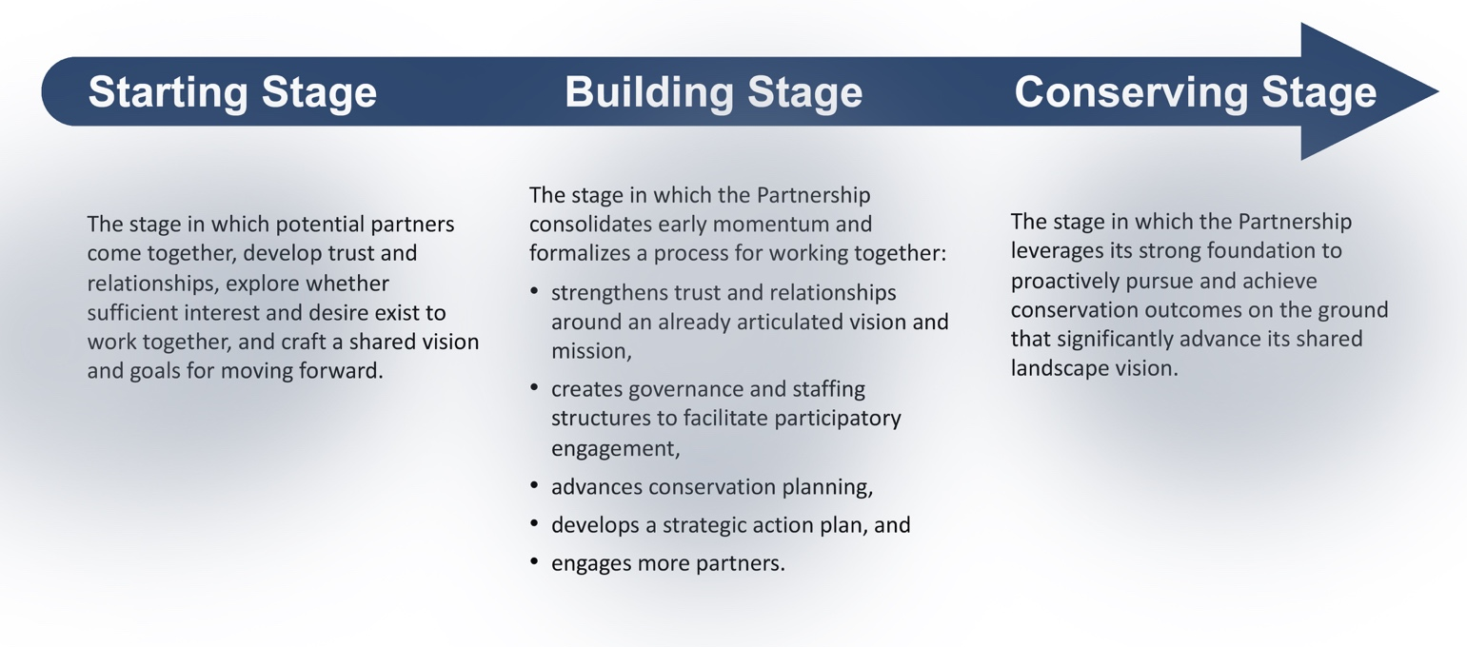

PRIORITY: CAPACITY BUILDING AND THE COLLABORATIVE PROCESS
The Catalyst Fund prioritizes investments in capacity building and the collaborative process—with the intent to accelerate a Partnership’s transition from Building Stage activities to Conserving Stage activities. The Fund will support the coordination function of Partnerships as well as specific Partnership-building activities (e.g., strategic planning, implementing communications frameworks, stakeholder engagement activities, science-based mapping and prioritization). The Fund does not support direct project-specific activities (e.g., trail construction costs, land acquisition or easement costs, or direct land management costs.). In all cases, applicants should clearly demonstrate how grant period activities will strengthen the fabric of the Partnership and advance conservation objectives.

Note: The Partnership Stages and Common Steps to Success Chart in the Applicant Guidance Document provides common activities at each stage of successful Partnership development. This Chart can be a helpful reference as applicants consider what types of activities are appropriate to include in a proposal.

PRIORITY: INDIGENOUS-LED AND PRIMARILY SERVING INDIGENOUS COMMUNITIES
A portion of the Catalyst Fund is reserved for investments in Indigenous leadership in landscape conservation. In addition to the three priorities above, applicants that meet this fourth priority may apply through a separate, reserved Indigenous-led Partnership application process.

Such Partnerships must be clearly led by Indigenous voices and primarily work to advance Indigenous conservation priorities. This can include Partnerships focused wholly on sovereign tribal lands and/or Partnerships focused on advancing and conserving Indigenous interests, territories, and rights across a broader, defined landscape.

See Section 2 of the Applicant Guidance Document for a summary of the priorities and requirements for Indigenous-led Partnership applicants.

- EVALUATION CRITERIA

Catalyst Fund requests will be evaluated based on the following criteria:

- Partnership Commitment: Demonstrated commitment to building a broad-based, collaborative Landscape Conservation Partnership (per RFP definition) as an effective and enduring vehicle for accelerating conservation impact at the landscape scale.
- Building Stage of Partnership Growth: Meets the definition of the Building Stage (per RFP definition) and is a Partnership poised for strategic action and catalytic growth.
- Conservation Value: Clear and compelling evidence of the ecological, cultural, and/or other ecosystem services value of the focal landscape, and the significance of the Partnership’s conservation work, including but not limited to its impact on climate resilience and habitat connectivity.
- Grant Period Impact: Clear and compelling articulation of how the proposed activities will strengthen the Partnership over the grant period in ways that advance progress toward conservation goals.
- Long-term Impact: Clear and compelling articulation of how the proposed grant period activities fit into a longer-term strategy to build an inclusive, enduring Partnership that achieves conservation goals, and how the grant will specifically catalyze realization of those longer-term goals.
In addition to the evaluation criteria above, the following will be considered in differentiating between equally meritorious proposals:

- Partnerships that include under-represented and historically marginalized communities, including but not limited to Indigenous communities, communities of color, and low-income communities.
- Partnerships located in regions with proven need and fewer examples of Landscape Conservation Partnerships.
- Proposals showcasing replicable innovation in the field.

- ELIGIBILITY & APPLICATION REQUIREMENTS

Eligibility: Applicants must be U.S. based non-profit organizations with approved IRS 501(c)(3) status. Indigenous-led Partnership applicants in the American West are also eligible to apply under IRS Code, Section 7871. The American West is defined to include the following states: Montana, Wyoming, Colorado, New Mexico, Arizona, Utah, Idaho, Nevada, California, Oregon, Washington, and Alaska.

Applicants may request one- or two-year grants of $10,000 to $25,000 in total. Grants can be awarded only in the 50 U.S. states. Landscape Conservation Partnerships are eligible to apply each year to the Catalyst Fund, but no Partnership may receive more than $25,000 over the first three years of the Fund (2019 funding round through 2021 funding round).

A Landscape Conservation Partnership should apply directly if it has appropriate IRS status. However, many Partnerships do not have formal 501(c)(3) or Section 7871 IRS status, and another organization may apply on behalf of a Partnership. In such cases, the applicant organization should be:
- The recognized lead convener of the Partnership;
- A recognized partner organization within the Partnership; or
- The fiscal sponsor organization of the Partnership.

While the lead applicant must have eligible IRS status, other involved partners (e.g., public agencies, community members, academic institutions, for-profit entities) may work on funded grant activities in informal or paid partner or contractor capacities.

Funding Restrictions
The Catalyst Fund invests in capacity building and the collaborative process of Landscape Conservation Partnerships as a mechanism to build enduring Partnerships that accelerate conservation impact.

Funding can be used for:
- Staff or contract support to advance and strengthen the fabric of the Partnership and accelerate conservation objectives in the specific ways.
- Direct costs—e.g., convening (space, food, lodging, and travel); web and print communications; outreach activities that educate and involve stakeholders; and costs involved in science-informed landscape conservation planning, mapping, and prioritization.
Funding cannot be used for:
- Academic research or writing.
- Capital campaigns or capital improvements.
- Office equipment.
- Acquisition of land or conservation easements.
- Other on-the-ground projects such as trail building or easement monitoring.
- Political lobbying.

Funding Match Requirement: Landscape Conservation Partnerships must demonstrate a funding match of at least 1:1. (See Indigenous-led Partnership exception below.) In-kind support can contribute to this match requirement, but at least 50% of the minimum match requirement must be direct support. Previously expended funds cannot be used as direct match. If matching funds are pending at time of application, applicants should indicate a time frame and the sources from which they anticipate securing other funding. For two-year grants, disbursement of second-year funds will only be awarded if the first-year match has been fully secured.

For the Indigenous-led Partnership portion of the Fund matching funds are not required, but proposals will be viewed favorably if they demonstrate: 1) in-kind support from partners (time, meeting space, other); 2) additional direct funding from other sources; and/or 3) a strategy for leveraging a Catalyst Fund grant to attract new funding to the Partnership.

Partnership Support: Landscape Conservation Partnerships must demonstrate commitment to the proposal from Partnership leadership. A support letter from the Partnership leadership body (and signed by at least three participating partner organizations) will be requested if an application reaches the full proposal stage.

- GRANTEE EXPECTATIONS

Funded Landscape Conservation Partnerships should expect and plan for the following:

- Peer Learning program: Funded Partnerships will be invited to select one to two representatives to participate in a Peer Learning cohort that will last the length of the grant period. The program will consist of bi-monthly 60- to 90-minute calls or webinars as well as an annual in-person convening for peer exchange, training opportunities, and mutual inspiration (travel funding will be provided). Network staff and leadership will also be available to help with problem-solving, providing background resources, and/or connecting grantees to other practitioners wrestling with similar issues.
- Grant Reporting: Funded Partnerships will be asked to provide a short, mid-grant written report as well as a final written report. Partnerships will be asked to document how the Catalyst Fund grant was spent and evaluate its impact.
- Long-term Tracking: The Network will track progress of funded Partnerships for five years after the grant period through a short annual survey.

- HOW TO APPLY
The Catalyst Fund has a two-stage application process, with an open call for pre-proposals followed by invitation-only full proposals. The application process is operated via the Network’s online application system. Pre-proposals for the 2020 funding round are due by 9 pm Eastern time on Friday, March 13, 2020.

Applicants should access the online application system and then select the appropriate process from the main dashboard. Indigenous-led Partnership may, if preferred, complete the pre-proposal using this Word form and submit via email to Jonathan Peterson.

To access the Network’s online application system, applicants need to set up an account by registering their organization. If applicants have applied to the Catalyst Fund previously, they will already be registered in the system and can directly log in to begin working on the new proposal. If applicants applied previously but do not recall their log-in credentials, they should contact Jonathan Peterson rather than re-registering.

Webinars to discuss the RFP: Webinars for potential Catalyst Fund applicants will be held on Monday, February 10th and Wednesday, February 19th at 2 pm Eastern Time. These will include a brief overview of the RFP, but will primarily be dedicated to responding to applicant questions. Recordings will be posted to the Network’s website upon conclusion.

If questions remain after a careful review of this RFP, the supplemental Applicant Guidance Document, and the webinars, inquiries (via email only) should be directed to Jonathan Peterson. Please indicate “Catalyst Fund RFP Question” in the subject line of your email.

~ ~ ~ ~ ~

