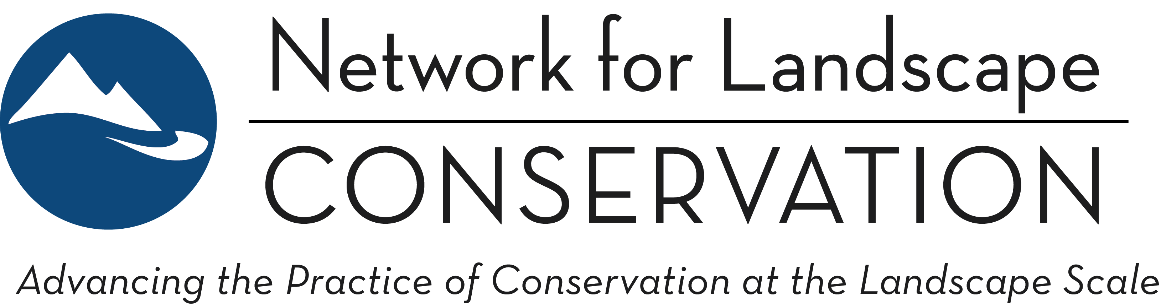

LANDSCAPE CONSERVATION CATALYST FUND
Applicant Guidance Document: 2022 Funding Round
March 14, 2022

This document is intended to clarify for applicants whether they are a strong fit with the current Catalyst Fund Request for Proposals, and to enable applicants to understand how best to shape their proposals in response to the current Fund parameters.

* * * *

WHAT MAKES A STRONG CATALYST FUND PROPOSAL?
Strong proposals to the Catalyst Fund will demonstrate how a modest strategic investment in collaborative infrastructure and coordination capacity will have significant impact in solidifying momentum, building a more robust Partnership, and accelerating progress towards achieving the group’s conservation and/or stewardship goals.
A portion of the Fund is dedicated to supporting Indigenous-led Partnerships. A strong Indigenous-led Partnership proposal will:
- Emerge from and be supported by the Indigenous community(s)—its purpose, design, and actions will originate from the Indigenous peoples the Partnership serves;
- Promote and reflect leadership and decision-making that directly serve the Indigenous community(s) involved in the Partnership;
- Integrate and support Indigenous Knowledge and the cultural lifeways of the community;
- Build capacity in the Indigenous community(s) to advance the conservation goals of the Partnership in the longer term.

For all proposals to the Catalyst Fund: The Fund makes investments in (a) Landscape Conservation Partnerships that are (b) at pivotal points in development. The following offers further details to help potential applicants understand whether they will fit these parameters:

- THE LANDSCAPE CONSERVATION PARTNERSHIP CHARACTERISTICS
As noted in the RFP: The Catalyst Fund focuses its investments on Landscape Conservation Partnerships that reflect the following characteristics: place-based; long-term conservation purpose; collaboratively governed; community grounded and inclusive; and informed.

ADDITIONAL BACKGROUND
The emphasis on “Landscape Conservation Partnerships” is not indicative of a specific focus on a fixed type of inter-organizational structure; rather, “Partnership” is used as an umbrella term to represent a variety of differing structures and degrees of formality for individuals and entities coming together in collaboration to advance enduring conservation and stewardship—this includes partnerships, collaboratives, networks, etc. The Fund focuses on groups of partners coming together in ways that transcend individual organizations’ efforts and that are working towards a shared, long-term conservation vision for a landscape. The emphasis is on a fully collaborative endeavor, rather than organizations “partnering” to achieve their own work.
Each of the five identified Partnership characteristics are explored in greater detail here:
PLACE-BASED: Focuses on a geographically explicit landscape.
The emphasis here is on Partnerships that are working within a readily identifiable and specific landscape—an interconnected geographic area that exceeds jurisdictional boundaries yet functions as and is perceived as a single unit because of ecological, geographical, cultural and/or other societal reasons. The landscape should be sufficiently large in scale to span parcel and political boundaries; encompass a diversity of landowner types, conservation issues, jurisdictions, and stakeholder interests; and allow for conservation impact at ecological scale. Yet it should be specific and contained enough that a community-grounded approach is feasible, and partners can work in ways that build enduring social capital within the geography. We welcome proposals from Partnerships working in all types of landscapes, including urban, suburban, rural, working, wild, and combinations thereof.
Examples that DO NOT align with this place-based characteristic:
- A Partnership that focuses on a general geography (e.g., “across the western United States,” “throughout the Northeast,”) or that is defined by the boundaries of a single state.
- A Partnership that focuses on a single issue or solution (e.g., building wildlife crossings, increasing green infrastructure, or creating model planning or easement language) irrespective of geography.
- A Partnership that focuses only on a specific “type” of land within a landscape (e.g., working only on public lands within the landscape).
- A Partnership that focuses exclusively on a single property or unit (e.g., a state park or a national forest).
- “Umbrella” proposals from an organization or collaborative that supports/serves a network of place-based Landscape Conservation Partnerships but is not itself pursuing a specific vision for a defined landscape.
NOTE: Indigenous-led Partnerships defined by the political boundaries of a Sovereign Tribal Nation ARE eligible for funding.

LONG-TERM CONSERVATION PURPOSE: Pursues a long-term and multi-issue conservation vision and purpose, with clearly identified conservation goals and outcomes that encompass people and nature.
The emphasis here is on Partnerships that are positioned to be enduring vehicles for achieving conservation goals in a landscape. Key here too is an emphasis on Partnerships that are multi-issue, focusing on sustaining the ecological integrity and resilience of the landscape and its communities as a whole.
Note: “Landscape conservation” is broadly understood to be a focus on sustaining or improving ecological integrity and functionality. The Fund is open to proposals from Partnerships that are working across any dimension of conservation, stewardship, and restoration.
Examples that DO NOT align with this long-term conservation purpose characteristic:
- Short-term, project-specific collaborations (e.g., a specific parcel acquisition or implementation of a specific land management activity).
- A Partnership convened for a specific, narrowly defined conservation objective, e.g.:
  - Advancing a single solution (e.g., building wildlife crossings) or a narrow objective (e.g. increasing wilderness designation) within the landscape;
  - Conserving a single species or ecosystem type (e.g., subalpine meadows) within the landscape;
  - Addressing a single, specific threat (e.g., invasive species) within the landscape.
- Partnerships convened to share information, allow for networking amongst practitioners, and/or provides capacity-building training within the landscape, but are not action-oriented toward achieving a shared conservation vision.
- Partnerships structured solely around campaigns against specific actions (e.g., opposition to a proposed mine or pipeline).
Note: single species conservation efforts ARE eligible for funding for Indigenous-led Partnerships.

COLLABORATIVELY GOVERNED: Embraces collaborative leadership that ensures participatory engagement from the breadth of partners.
The emphasis here is on Partnerships that work in a fully collaborative fashion. While one (or a few) organizations may play a lead convening or coordination role, inter-organizational leadership and proactive participatory engagement should be clearly evident, with the breadth of partners co-creating vision, purpose, and progress.
Examples that DO NOT meet this collaboratively governed characteristic:
- Programs of a single organization, even if additional partners are engaged to achieve program objectives (e.g., a land trust’s conservation program that regularly relies on partnering to complete conservation deals).

COMMUNITY-GROUNDED AND INCLUSIVE: Engages a breadth of stakeholders on the landscape, and bridges sectors, interests, and cultures to find common ground.
The emphasis here is on Partnerships that are working within landscape and place, engaging authentically in a community-grounded fashion to build a collective voice for the future of the landscape. The emphasis too is on Partnerships that strive to be inclusive, and that are proactively engaging the breadth of perspectives within a landscape to build bridges across cultures, interests, and sectors in pursuit of a shared conservation vision for the future of a landscape.
Examples that DO NOT meet this community-grounded and inclusive characteristic:
- A Partnership driven by external entities or individuals that do not engage at the community level within the landscape.
- A Partnership that is primarily comprised of a narrow range of stakeholders, and does not work to build connections to other stakeholders within the landscape.
- A Partnership comprised of too few partners. [Note: there is not a precise fixed size criterion here (the context of any landscape is unique) but the Partnership should engage a broad range of stakeholders and perspectives.]

INFORMED: Uses ecological, cultural, traditional, and/or social information to inform its work and build a shared foundation of knowledge.
The emphasis here is on using knowledge to inform action. The expectation is that a Partnership’s conservation work should be grounded in robust science and knowledge—recognizing that knowledge sources are not limited to western ecological science but include Indigenous Knowledges and additional cultural and social knowledges.
Examples that DO NOT meet this informed characteristic:
- A Partnership that focuses primarily on research (as opposed to the action-oriented implementation of a science- and knowledge-informed conservation vision).

ADDITIONAL BACKGROUND: TRANSFORMATIVE COLLABORATION
It has become increasingly understood that the conservation movement has historically marginalized and excluded groups of people and has perpetuated colonialist mentalities—we can no longer hide behind the pretense that we are doing “good” simply by conserving, stewarding, and/or restoring lands and waters. Conservation at its most basic is a human decision about how we interact with land. How we make such decisions—and who has power to make them—matters. Collaboration is widely recognized as an essential element of conservation, yet conservation has become very comfortable with “transactional” collaboration: come to our table to help us solve the problem(s) that we want to solve. Such collaboration largely does not push beyond conservation’s historical legacy, nor does it truly share power—formally or informally—in any real manner. “Transformative” collaboration though brings people together to co-create “the table.” Such collaboration begins by first building a shared and inclusive understanding of the problem(s) that need to be addressed and considering a shared vision for what the future could look like—and only then turning to consider possible solutions and pathways forward.
Landscape Conservation Partnerships that embody transformative collaboration—by sharing power with those that have been historically excluded and building understanding and connection across difference—can be essential conduits for sustaining the ecological integrity of our landscapes and fostering a more just and equitable future for our human communities. As the Network itself works to become more inclusive of historically marginalized and excluded voices and explores how landscape conservation can be a tool in service of a just and equitable future, we are looking to support Partnerships that are engaged in this journey as well. Together, our hope is that we can join in the effort of shifting the culture of conservation from transactional to transformative collaboration.

- PIVOTAL POINTS IN PARTNERSHIP DEVELOPMENT
As noted in the RFP: The Fund currently targets Partnerships at pivotal points in their development where modest investments in collaborative infrastructure and coordination capacity can shift the trajectory of conservation outcomes in the landscape.
Specifically, the Catalyst Fund prioritizes the transition from collective vision to collective action. The shift from vision to implementation and action often requires increased time and energy, and investments in coordination capacity and/or collaborative infrastructure at this point can be critical to significantly accelerating forward progress on conservation outcomes.

ADDITIONAL BACKGROUND
Although every Partnership must respond to the unique context of its landscape and there is no cookie-cutter solution to building a Partnership, many follow similar progressions of development. A generalized framework can be drawn of three developmental stages for Partnerships: “Starting,” “Building,” and “Conserving” (see diagram below). This framework is offered primarily as a heuristic, as in practice the stages are unlikely to be entirely discrete nor is the relationship between stages necessarily linear.
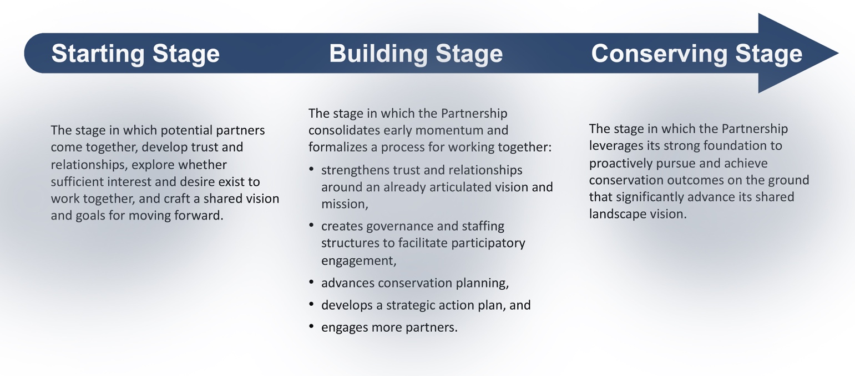

The Catalyst Fund prioritizes the transition from collective vision to collective action. At this inflection point, participants have already demonstrated a commitment to the Partnership through a significant investment of time and energy to build relationships and establish the foundation of trust necessary for working together. Early forward momentum is evident around the developing of the purpose of the shared work, with partners establishing vision/mission and goals. Carrying this momentum forward into implementation and action though requires increasing time and energy, and a barrier to success here can be the lack of backbone organizational support and coordination capacity. In the generalized Partnership development framework above, this is the “Building” stage.
Because Partnership development IS individualized, Partnerships are welcome to submit proposals designed to help them accelerate progress through other pivotal points in development. Applicants are encouraged to reach out the Catalyst Fund Manager prior to doing so to ensure fit. A critical question—for any proposal but especially proposals from more advanced Partnerships—will be whether a modest investment will have significant impact on the Partnership’s capacity to achieve its conservation goals.
The Catalyst Fund does not invest in launching new Partnerships. Partnerships currently in the process of forming and coming together—that is, Partnerships in the Starting stage—should look to the Catalyst Fund in future years when forward momentum has accrued and when a small investment can accelerate the Partnership forward on its path to conservation impact.

APPENDIX: ADDITIONAL BACKGROUND ON FUND PURPOSE
As noted in the RFP: The Catalyst Fund aims to accelerate the pace and practice of collaborative landscape conservation across the United States. The Fund makes strategic investments in strengthening the collaborative infrastructure and coordination capacity of place-based, community-grounded Landscape Conservation Partnerships—building in landscapes across the country the enduring collaborative capacity that is necessary to achieve bigger, better, and more durable conservation and stewardship over the long term.

ADDITIONAL BACKGROUND:
Landscape conservation is an approach that brings people together across geographies, sectors, and cultures to collaborate on conserving our important landscapes and the myriad ecological, cultural, and economic benefits they provide. This highly collaborative practice embraces the complexity of working at scale to connect and protect irreplaceable landscapes—across public and private lands, and from our cities to our wildest places.
The Catalyst Fund emerged from a series of observations:
- The 21st Century challenges we face—climate change, the biodiversity crisis, accelerating land-use conversion and landscape fragmentation, the environmental justice crisis, and more—are existential and systems-level, and working at the landscape scale is essential for scaling our response to the match the scale of these challenges;
- Board, enduring collaboration is essential to achieving lasting conservation success across whole landscapes;
- Building and sustaining effective collaboration requires dedicated time and resources, and a specific skillset and approach—all of which requires strategic and dedicated investments;
- Yet funding and capacity-building investments to directly support and advance collaboration are scarce and difficult to acquire.
This is the collaboration disconnect: it has become almost universally understood that successful landscape conservation is predicated on collaboration, and yet little funding is available to landscape conservation initiatives for strengthening their process of collaboration. The Catalyst Fund is designed to address this critical disconnect directly, providing financial and capacity-building support to allow broad-based, enduring Partnerships to strategically invest in their collaborative infrastructure and coordination capacity. These investments are intended to catalyze growth and better position Partnerships to achieve long-term landscape conservation success.

