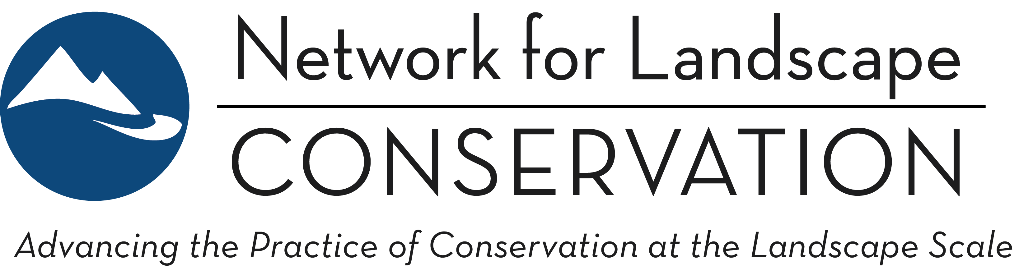

CATALYST FUND
Applicant Guidance Document: 2023 Funding Round
March 15, 2023

This document is intended to clarify for applicants whether they are a strong fit with the current Catalyst Fund Request for Proposals, and to enable applicants to understand how best to shape proposals in response to the current Fund parameters.

Included in this Guidance Document:
Section 1: What makes a strong Catalyst Fund proposal?........................... Page 1
A: Landscape Conservation Partnership characteristics................... Page 2
B: Pivotal points in Partnership development .................................. Page 5

Section 2: Understanding collaborative capacity......................................... Page 7

Appendix: Additional background on Fund purpose……............................... Page 10

* * * *

SECTION 1: WHAT MAKES A STRONG CATALYST FUND PROPOSAL?
Strong proposals to the Catalyst Fund will be clearly structured around advancing specific elements of collaborative capacity within a Landscape Conservation Partnership (see SECTION 2: COLLABORATIVE CAPACITY to better understand what we consider collaborative capacity). Furthermore, strong proposals will demonstrate how a modest strategic investment in collaborative capacity will have significant impact in solidifying momentum, building a more robust Partnership, and accelerating progress towards achieving the group’s conservation and/or stewardship goals.
A portion of the Fund is dedicated to supporting Indigenous-led Partnerships. A strong Indigenous-led Partnership proposal will:
- Emerge from and be supported by the Indigenous community(s)—its purpose, design, and actions will originate from the Indigenous peoples the Partnership serves;
- Promote and reflect leadership and decision-making that directly serve the Indigenous community(s) involved in the Partnership;
- Integrate and support Indigenous Knowledge and the cultural lifeways of the community;
- Build capacity in the Indigenous community(s) to advance the conservation and stewardship goals of the Partnership in the longer term.
For all proposals to the Catalyst Fund: The Fund makes investments in (a) Landscape Conservation Partnerships that are (b) at pivotal points in development. The following offers further details to help potential applicants understand whether they will fit these parameters:

- LANDSCAPE CONSERVATION PARTNERSHIP CHARACTERISTICS
As noted in the RFP: The Catalyst Fund seeks Landscape Conservation Partnerships that reflect the following characteristics: place-based; long-term conservation purpose; collaboratively governed; community-grounded and inclusive; and informed.

ADDITIONAL BACKGROUND
The emphasis on “Landscape Conservation Partnerships” is not indicative of a specific focus on a fixed type of inter-organizational structure; rather, “Partnership” is used as an umbrella term to represent a variety of differing structures and degrees of formality for individuals and entities coming together in a partnership, collaborative, or network to advance enduring conservation and stewardship. The Fund focuses on groups of partners coming together in ways that transcend individual organizations’ efforts and that are working towards a shared, long-term conservation vision for a landscape. The emphasis is on a fully collaborative endeavor, rather than an organization that “partners” with other entities or organizations to achieve its own work.
Each of the five Partnership characteristics the Catalyst Fund seeks in successful applicants are explored in greater detail here:
PLACE-BASED: Focuses on a geographically explicit landscape.
The emphasis here is on Partnerships that are working within a readily identifiable and specific landscape—an interconnected geographic area that exceeds jurisdictional boundaries yet functions as and is perceived as a single unit because of ecological, geographical, cultural and/or other social reasons. There is no fixed criterion for how large a landscape should be; However, the landscape should be sufficiently large in scale to span parcel and political boundaries; encompass a diversity of landowner types, conservation issues, jurisdictions, and stakeholder interests; and allow for conservation and stewardship impact at ecological scale. Yet the landscape should be specific and contained enough that a community-grounded approach is feasible, and partners can work in ways that build enduring social capital within the geography. We welcome proposals from Partnerships working in all types of landscapes, including urban, suburban, rural, working, wild, and combinations thereof.
Examples of Partnerships that WILL NOT successfully align with this place-based characteristic:
- A Partnership that focuses on a general geography (e.g., “across the western United States,” “throughout the Northeast,”) or that is defined by the boundaries of a single state (e.g., “within Connecticut,” or “throughout Wyoming”).
- A Partnership that focuses on a single issue or solution (e.g., building wildlife crossings, increasing green infrastructure, or creating model planning or easement language) irrespective of geography.
- A Partnership that focuses only on a specific “type” of land within a landscape (e.g., working only on public lands within the landscape).
- A Partnership that focuses exclusively on a single property or unit (e.g., a state park or a national forest).
- “Umbrella” proposals from an organization or collaborative that supports/serves a number of place-based Landscape Conservation Partnerships.
NOTE: Indigenous-led Partnerships defined by the political boundaries of a Sovereign Tribal Nation ARE eligible for funding.

LONG-TERM CONSERVATION PURPOSE: Pursues a long-term and multi-issue conservation and stewardship vision and purpose, with clearly identified goals and outcomes that encompass people and nature.
The emphasis here is on Partnerships that are positioned to be enduring vehicles for achieving conservation goals in a landscape. Key here too is an emphasis on Partnerships that are multi-issue, focusing on sustaining the ecological integrity and resilience of the landscape and its communities as a whole.
Note: “Landscape conservation” is broadly understood to be a focus on sustaining or improving ecological integrity and functionality. The Fund is open to proposals from Partnerships that are working across any dimension of conservation, stewardship, and restoration.
Examples of Partnerships that WILL NOT successfully align with this long-term conservation purpose characteristic:
- Short-term, project-specific collaborations (e.g., created to achieve a specific parcel acquisition or implementation of a specific land management activity).
- A Partnership convened for a specific, narrowly defined conservation objective, e.g.:
  - Advancing a single solution (e.g., building wildlife crossings) or a narrow objective (e.g. increasing wilderness designation) within the landscape;
  - Conserving a single species or ecosystem type (e.g., subalpine meadows) within the landscape;
  - Addressing a single, specific threat (e.g., invasive species) within the landscape.
- Partnerships structured solely around campaigns opposing specific actions (e.g., opposition to a proposed mine or pipeline).
Note: single species conservation and stewardship efforts ARE eligible for funding for Indigenous-led Partnerships.

COLLABORATIVELY GOVERNED: Embraces collaborative leadership and participatory engagement and decision-making.
The emphasis here is on Partnerships that work in a fully collaborative fashion. While one (or a few) organizations may play a lead convening or coordination role, inter-organizational leadership and proactive participatory engagement should be clearly evident, with the breadth of partners co-creating vision, purpose, and progress.
Examples of Partnerships that WILL NOT successfully align with this collaboratively governed characteristic:
- Programs of a single organization, even if additional partners are engaged to achieve program objectives (e.g., a land trust’s conservation program that regularly relies on partnering to complete conservation deals).

COMMUNITY-GROUNDED AND INCLUSIVE: Engages a breadth of collaborators and partners on the landscape, bridging interests, perspectives, and cultures to find common ground.
The emphasis here is on Partnerships that are working within landscape and place, engaging authentically in a community-grounded fashion to build a collective voice for the future of the landscape. The emphasis too is on Partnerships that strive to be inclusive, and that are proactively engaging the breadth of perspectives within a landscape to build bridges across cultures, interests, and sectors in pursuit of a shared conservation and stewardship vision for the future of a landscape.
Examples of Partnerships that WILL NOT successfully align with this community-grounded and inclusive characteristic:
- A Partnership driven by external entities or individuals that do not engage at the community level within the landscape.
- A Partnership that is primarily comprised of a narrow range of stakeholders, and does not work to build connections to other interests, entities, and communities within the landscape.
- A Partnership comprised of too few partners. [Note: there is not a precise fixed size criterion here (the context of any landscape is unique) but the Partnership should engage a broad range of groups, interests, and perspectives.]

INFORMED: Uses ecological, cultural, traditional, and/or social information to inform its work and build a shared foundation of knowledge.
The emphasis here is on using knowledge to inform action. The expectation is that a Partnership’s conservation and stewardship work should be grounded in robust science and knowledge—recognizing that knowledge sources are not limited to western ecological sciences but include Indigenous Knowledges and additional cultural and social knowledges.
Examples of Partnerships that WILL NOT successfully align with this informed characteristic:
- A Partnership that focuses primarily on research (as opposed to the action-oriented implementation of a science- and knowledge-informed conservation vision).

ADDITIONAL BACKGROUND: TRANSFORMATIVE COLLABORATION
It is increasingly clear that the conservation movement has historically marginalized and excluded groups of people and has perpetuated colonialist mentalities—as practitioners, it is no longer acceptable for us to hide behind the pretense that we are doing “good” simply by conserving, stewarding, and/or restoring lands and waters. Conservation and stewardship at the most basic level is a human decision about how we interact with land. How we make such decisions—and who is granted power to make them—matters.
Collaboration is widely recognized as an essential element of conservation and stewardship at the landscape scale, yet the conservation movement has become very comfortable with a ‘transactional’ approach to collaboration: come to our table to help us solve the problem(s) that we want to solve. Such collaboration largely does not push beyond or overcome conservation’s historical legacy, nor does it truly share power—formally or informally—in any real manner. A deeper, more authentic, and ‘transformative’ approach to collaboration is rooted in bringing people together to co-create ‘the table.’ Such collaboration begins by first building a shared and inclusive understanding of the problem(s) that need to be addressed and considering a shared vision for what the future could look like—and only then turning to consider possible solutions and pathways forward.
The Catalyst Fund recognizes that Landscape Conservation Partnerships that embody transformative collaboration—by sharing power with those that have been historically excluded and building understanding and connection across difference—can be essential conduits for sustaining the ecological integrity of our landscapes and fostering a more just and equitable future for our human communities. As the Network itself works to become more inclusive of historically marginalized and excluded voices and explores how landscape conservation and stewardship can be a tool in service of a just and equitable future, we seek to support Partnerships that are engaged in striving for transformative collaboration as well. Our hope is that we can together join in the effort of shifting the culture of conservation from transactional to transformative collaboration.

- PIVOTAL POINTS IN PARTNERSHIP DEVELOPMENT
As noted in the RFP: The Fund seeks Partnerships at pivotal points in their development where modest investments in collaborative capacity can shift the trajectory of conservation and stewardship outcomes over time in the landscape.
Specifically, the Catalyst Fund prioritizes the transition from collective vision to collective action. The shift from vision to implementation and action often requires increased time and energy, and investments in coordination and collaborative capacity at this point can be critical to significantly accelerating forward progress on conservation and stewardship outcomes.

ADDITIONAL BACKGROUND
Although every Partnership must respond to the unique biophysical and sociopolitical context of its landscape (there is no cookie-cutter solution to building a Partnership), many follow similar progressions of development. A generalized framework can be drawn of three idealized developmental stages for Partnerships: “Starting,” “Building,” and “Conserving” (see diagram below). This framework is offered primarily as a heuristic, as in practice the stages are unlikely to be entirely discrete nor is the relationship between stages necessarily linear.
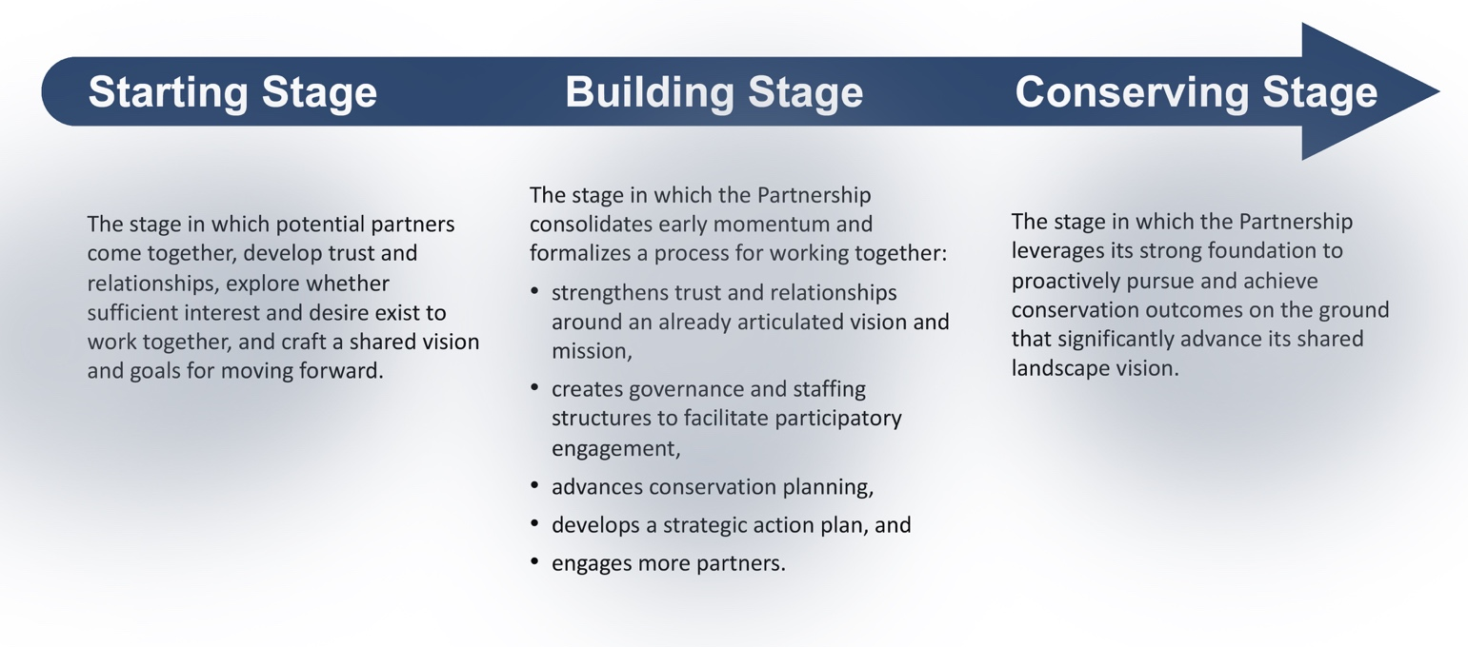
Figure 1: A generalized framework for understanding idealized stages of Partnership development.

The Catalyst Fund prioritizes the transition from collective vision to collective action. At this inflection point, participants have made a significant investment of time and energy in building relationships and establishing foundational trust; early forward momentum is evident in the developing of shared purpose and establishing vision/mission and goals. At this point, it is clear that the sociopolitical context and conditions are conducive to allowing productive and impactful long-term collaboration, and that partners are committed to exploring this opportunity. Carrying this momentum forward into implementation and action though requires increasing time and energy, and a barrier to success here very often is the lack of coordination capacity and backbone organizational support. In the generalized Partnership development framework above, this is the “Building” stage.
Because Partnership development IS individualized, Partnerships are welcome to submit proposals designed to accelerate progress through other pivotal points in development. Applicants are encouraged to reach out to the Catalyst Fund Manager prior to doing so to ensure fit. A critical question—for any proposal but especially proposals from more advanced Partnerships—will be whether a modest investment will have significant impact on the Partnership’s capacity to achieve its conservation and stewardship goals over the long term.
The Catalyst Fund does not consider proposals for new Partnerships. Partnerships currently in the process of forming and coming together—that is, Partnerships in the Starting stage—should look to the Catalyst Fund in future years when forward momentum has accrued and when a small investment can accelerate the Partnership forward on its path to conservation and stewardship impact.

SECTION 2: UNDERSTANDING COLLABORATIVE CAPACITY
Collaborative capacity can be understood as the elements that allow groups of partners to be capable of functioning effectively across organizations/entities to achieve a shared purpose. Effective collaborative capacity is what allows a group of partners to successfully produce more impactful and durable conservation and stewardship outcomes than can arise from any single organization working on its own.
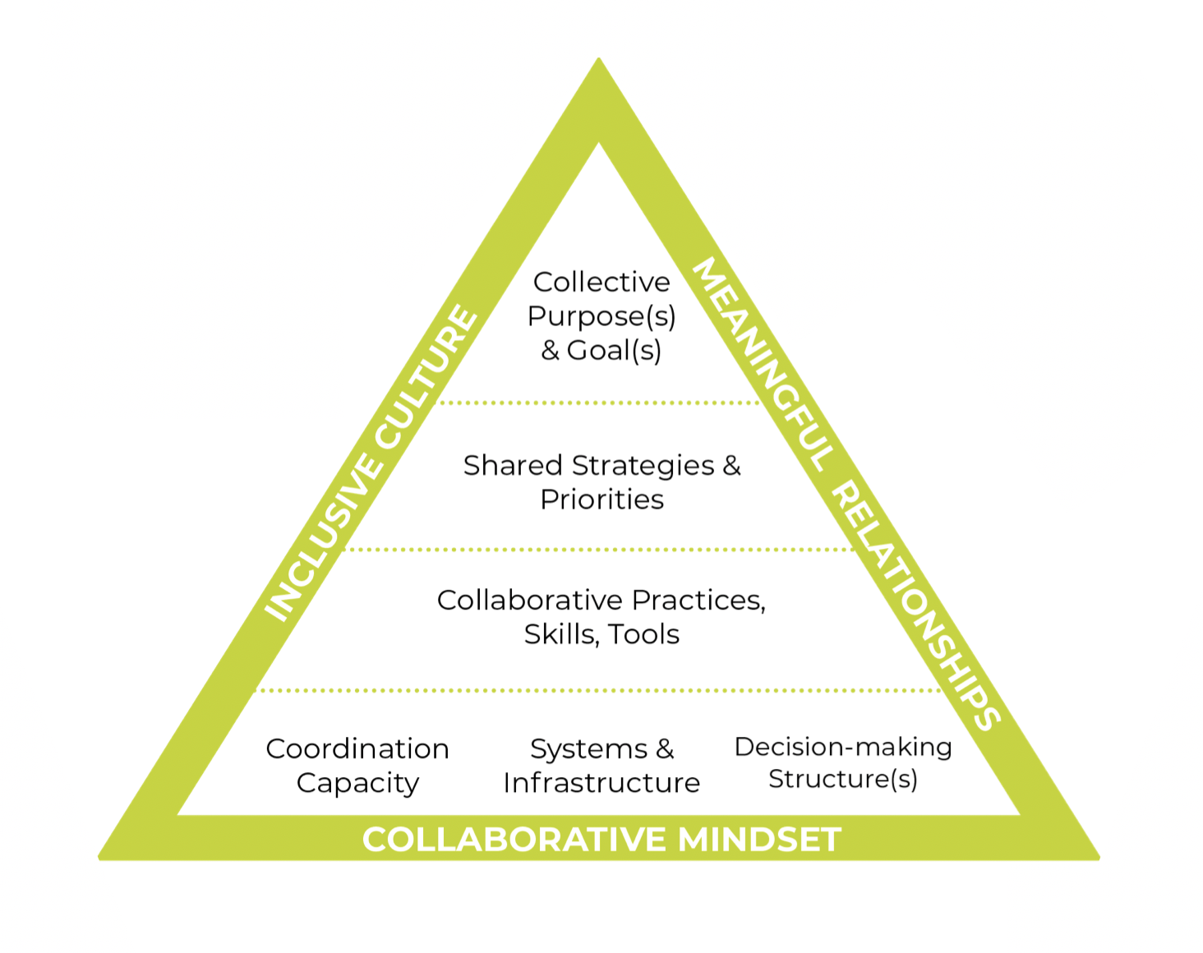
Our colleagues at the California Landscape Stewardship Network have recently released a publication (Increasing Collaborative Capacity and Infrastructure for Landscape Stewardship) that captures a framework for clarifying the needs that allow collaboratives to perform for landscape outcomes. This framework describes six structural elements of collaborative capacity: collective purposes and goals; shared strategies and priorities; collaborative practices, skills and tools; systems and infrastructure; decision-making structures; and coordination capacity. The framework also identifies three binding elements of collaborative capacity: inclusive culture; meaningful relationships, and collaborative mindset.
Figure 2: A Collaborative Capacity Framework (adapted from "Increasing Collaborative Capacity and Infrastructure for Landscape Stewardship")
The structural elements of this framework are the specific—and fundable—needs that create the “scaffolding” that allows a collaborative to function effectively over time. The binding elements reflect the quality of the scaffolding and are the enabling conditions that can set the collaborative alight: with the structural elements in place a collaborative can persist at a basic functioning level, but it is the concomitant development of the binding elements that allows a collaborative to blossom and optimize performance.
Collaborative capacity can be thought of as a keyhole: when the structural elements are resourced and developed, and when the binding elements are attended to and intentionally cultivated and stewarded, a suite of partners can come together and turn in lockstep to unlock the door of potential for accelerating conservation and stewardship outcomes over time in the landscape they care for.

STRUCTURAL ELEMENTS: The following provides greater clarity on the six structural elements of collaborative capacity, and specific examples of fundable components of each element (adapted from Appendix A of the Increasing Collaborative Capacity publication):
- Coordination Capacity—the basic staffing support and coordination “glue” for holding together the logistics of the collaborative:
  - Backbone and administrative capacity via dedicated staff or an organization that provides essential facilitation, meeting management, communications, progress tracking and measurement, collective administrative needs, and more.

- Systems and Infrastructure—the basic operational and communication structures that allow for internal connectivity, alignment, and information flow:
  - Communications and data-sharing systems for dissemination of resources (e.g., information and tools).
  - Cross network/partnership connectivity resources to deliver facilitated in-person and virtual multi-stakeholder convenings, develop plans, and build trust and community connections.
  - Evaluation and measurement tools to gauge and grow partnership impact and health.
  - Fiscal management support to oversee collective business needs.
  - Fundraising and grant-writing support to enable planning, design, and implementation of collective goals.
  - Support for equitable participation and engagement to ensure responsive, durable project or program design.

- Decision-Making Structures—Partnerships or collaboratives exist and operate in the space between organizations, which necessitates transparent and commonly understood pathways for reaching and executing decisions:
  - Strong governance models that steer a co-created vision and ensure equity and accountability.
  - Technical services and support to meet science, technology, engagement, and other project- and program-specific needs.

- Collaborative Practices, Skills, and Tools—working in the space between organizations requires a unique skillset, and this knowledge and expertise differs from what we have traditionally been called to deliver in our conservation and stewardship backgrounds:
  - Skill-building and competency-based training opportunities to build key collaborative leadership abilities and culture.

- Shared Strategies and Priorities—a shared and clear understanding of how the partnership or collaborative is going to work together and what it will strive to do:
  - Strategic plan and/or roadmap development to outline the collective vision, goals, work plans, actions, and activities that provide a shared understanding of partners’ roles, resources, and capacities.

- Collective Purpose and Goals—the “north star” or the animating purpose that is holding the partnership together:
  - Agreements (e.g., MOU, charter, etc.) to outline partnership's collective vision, purpose, and desired collective impacts, including partner roles.

BINDING ELEMENTS: The three binding elements are qualities to be embodied in all aspects of collaborative work and can be thought of as enabling conditions for effective collaboration. These are interwoven and support/build from one another:
- Collaborative Mindset—comprised of a deep belief in the power of collaboration, a commitment to working through collaborative approaches, and an understanding of—and ability to benefit from and/or overcome—the unique opportunities and challenges that arise in working through collaborative rather than organizational pathways.
- Inclusive Culture—comprised of fostering a common sense of belonging across all participants, the valuing of all voices and perspectives within the landscape, and a centering of those communities that have been systematically marginalized.
- Meaningful Relationships—comprised of a recognition, honoring, and celebrating of the “humanness” that we all carry with us, and an intentional and caring exploration of how our individual humanness intersects with and connects to the humanness of those around us.

Together the nine elements of collaborative capacity are what allows a partnership or collaborative to achieve durable and inclusive environmental and social outcomes over the long term in the landscape in which it operates. In preparing your proposal for the Catalyst Fund, we encourage you to reflect on how you see your Partnership in its current form reflected in this framework, and where you are hoping to utilize Catalyst Fund support to strengthen or build new collaborative capacity.

APPENDIX: ADDITIONAL BACKGROUND ON FUND PURPOSE
As noted in the RFP: The Catalyst Fund aims to accelerate the pace and practice of collaborative landscape conservation and stewardship across the United States. The Fund makes strategic investments in strengthening the collaborative capacity of place-based, community-grounded Landscape Conservation Partnerships. These investments are intended to better position Partnerships to achieve long-term conservation and stewardship success, building in landscapes across the country the enduring collaborative capacity needed to address systems-level challenges like the interwoven biodiversity, climate, and environmental injustice crises.

ADDITIONAL BACKGROUND:
Landscape conservation is an approach that brings people together across geographies, sectors, and cultures to collaborate on conserving and stewarding our important landscapes and the myriad ecological, cultural, and economic benefits they provide. This highly collaborative practice embraces the complexity of working at scale to connect, protect, and care for irreplaceable landscapes—across public and private lands, and from our cities to our wildest places.
The Catalyst Fund emerged from a series of observations:
- Our 21st Century challenges—climate change, biodiversity loss, systemic environmental injustice, and more—are existential and systems-level, and working at the landscape scale is essential for scaling our response to the match the scale of these challenges;
- Board, enduring collaboration is essential to achieving lasting conservation success across whole landscapes;
- Building and sustaining effective collaboration requires dedicated time and resources, and a specific skillset and approach—all of which requires strategic and dedicated investments;
- Yet funding and capacity-building investments to directly support and advance collaboration are scarce and difficult to acquire.
This is the collaboration disconnect: it has become almost universally understood that successful landscape conservation and stewardship is predicated on collaboration, and yet little funding is available to landscape initiatives for strengthening their process of collaboration. The Catalyst Fund is designed to address this critical disconnect directly, providing financial and capacity-building support to allow broad-based, enduring Partnerships to strategically invest in their collaborative capacity. These investments are intended to catalyze growth and better position Partnerships to achieve long-term landscape conservation success.

