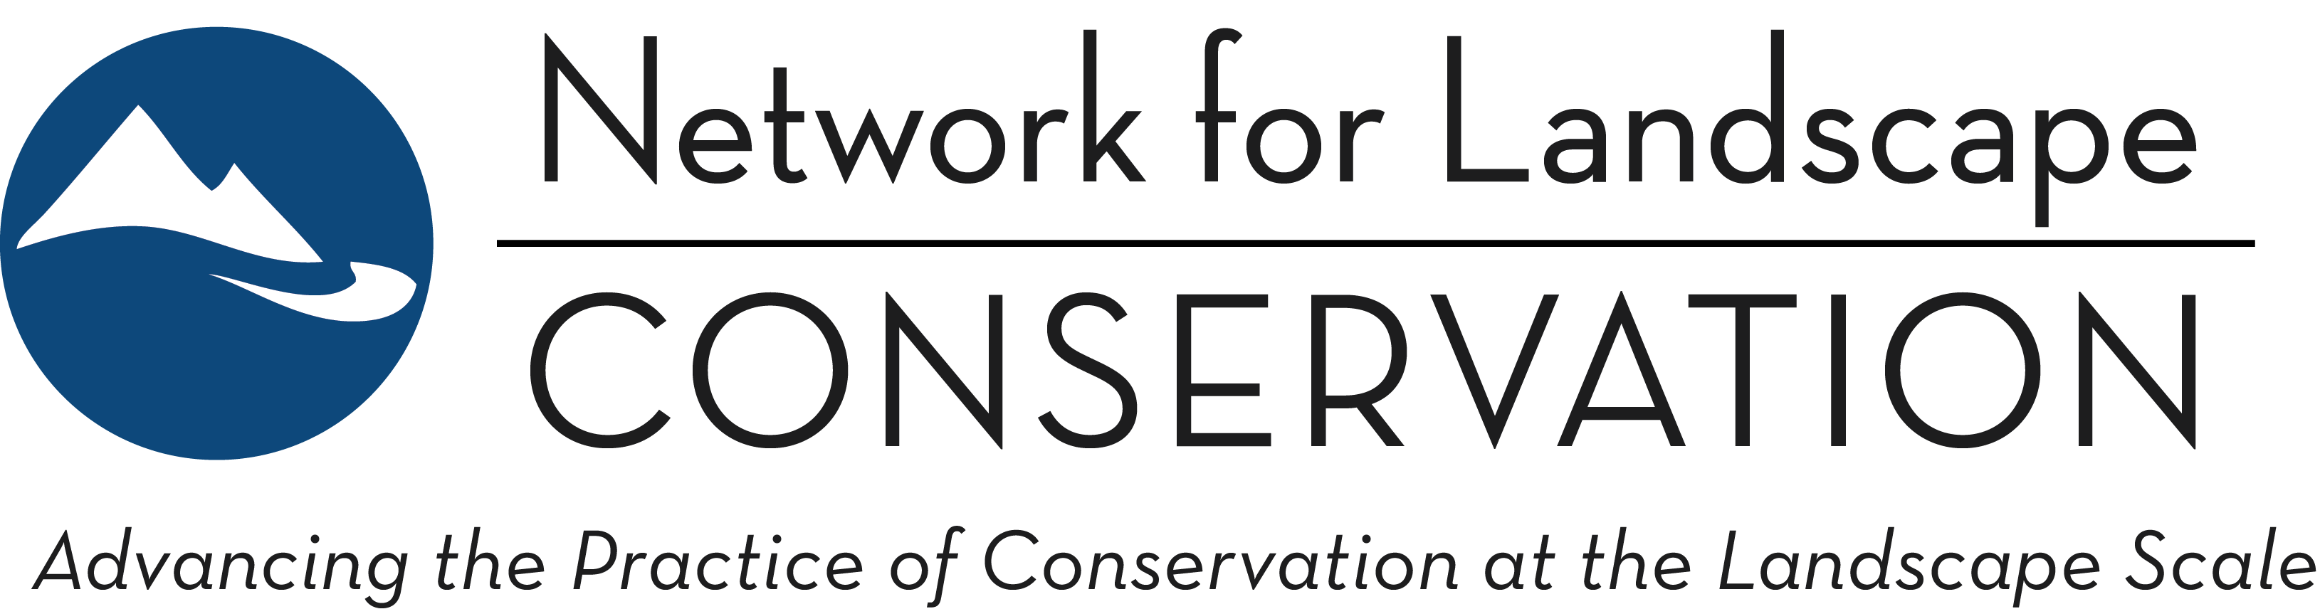

CATALYST FUND
2024 Funding Round—Proposal Form
March 2024

Tribal-led Partnerships may submit a proposal, if preferred, using this Word form application instead of the online application process. All other applicants should submit their application via the online application process.

Is this a proposal for a Tribal-led Partnership?
A portion of the Catalyst Fund is dedicated to supporting Indigenous leadership in landscape conservation and stewardship. Is this a proposal that emerges from and is supported by the Tribal governments and/or Indigenous communities within a landscape?
Yes No
If yes, you may continue with a submission via this word form application. If no, please submit your application via the online application process.

Once completed, email this Word form to Sara Mosser with a subject line of Catalyst Fund Proposal Submission.

ELIGIBILITY SCREEN
Please use this initial section as a self-administered eligibility screen. If you answer “no” to any of these questions, you should not proceed with your application: you will not be a strong fit with the Catalyst Fund and will not receive a grant award.

- The Partnership seeking funding is working within a specific, defined landscape.
Refer here to see what the Catalyst Fund considers to be specific, defined landscapes.
Yes No

- The proposal is for a long-term, enduring Partnership.
A Partnership focused on achieving a specific, short-term project (e.g. to build a trail or complete a land deal) would answer “no” here.
Yes No

- The long-term purpose of the Partnership seeking funding is to advance conservation and/or stewardship goals within the landscape.
Yes No

- The proposal is structured around investing in the Partnership’s collaborative capacity to better position it long-term to achieve its conservation and/or stewardship goals.
Requests for funding support for direct conservation project implementation [e.g. land acquisitions or stewardship costs] would answer “no” here.
Yes No

-- Continue on the next page to complete the proposal --

PROPOSAL
Proposal Title:
Provide a brief, one-sentence title for your proposal.

Proposal Summary:
In one paragraph, succinctly summarize what the funding will enable you to accomplish and the impact that this will have on your Partnership’s ability to achieve its conservation and stewardship goals within your defined landscape. This may be used in public descriptions of awarded grants.
Requested character limit: 500

Name of Landscape Partnership:
Website (if available):
Year Launched:

Grant Request: 1 year or 2 year
Grant Request Amount: (Not to exceed $25,000)

Anticipated approximate budget of your Partnership for 2024:
Please do not provide the annual budget for the applicant organization (if an organization is applying on behalf of a Partnership); instead provide an estimate for the core operating budget of the actual Partnership.

SELECTION QUESTIONS
Geography: In which geographic region does this Partnership operate?
Select the region that best fits, recognizing that some partnerships may cross these arbitrary boundaries; more than one region can be selected. View this map if you are unsure which region your landscape is located in.
Northeast: New England
Northeast: Middle Atlantic
South: South Atlantic
South: East South Central
South: West South Central
Midwest: East North Central
Midwest: West North Central
West: Mountain
West: Pacific

Size: Size (in acres) of the Partnership’s landscape?
<500,000
500,000-999,999
1 million-5 million
6 million-10 million
11 million-50 million
51 million-100 million
>100 million

Meeting Frequency: How often does the core group of partners within the Partnership meet?
Monthly
Quarterly
Annually
Less Frequently
Other?
Comment:

Current Staffing: How is the Partnership staffed/coordinated?
A paid full-time (.76 or greater FTE) coordination position is staffed.
A paid part-time (.25-.75 FTE) coordination position is staffed.
A paid limited part-time (less than .25 FTE) coordination position is staffed.
Staff member(s) from partner organizations provide part-time, undedicated coordination support.
Community members or other individuals provide volunteer coordination support.
No coordination support is currently provided.

PROPOSAL NARRATIVE:
As you consider your answers to the following questions, we encourage you to clearly convey how your Partnership reflects the Catalyst Fund's prioritized Partnership characteristics, and how a grant award will catalyze your Partnership at a critical point in its development, in ways that change the trajectory of conservation and stewardship outcomes on your landscape over the long term.
We request that each of the four narrative questions below be addressed in 500 words or fewer. There is a margin of buffer built into the character limits set below, as we don’t believe spending extensive time editing slightly longer responses down to hit precise limits is productive or beneficial. However, your responses to the following four narrative questions should not exceed five pages in length in total.

Question 1: The Why—Tell us why your Landscape Partnership exists?
Ground us briefly in the geography and context of your landscape—What is the geographic extent of your landscape and what elements contribute to the significance of this landscape? Additionally, we want to understand the shared purpose of your Partnership—what conservation and stewardship outcomes are partners coming together to work towards? We will be looking for a clear sense of the vision, mission, goals, and strategies of your Partnership.
Requested character limit: 3500

Question 2: The Who—Introduce us to your Landscape Partnership.
We encourage you to share the story of who comprises your Partnership and how it operate. We’re less interested in the naming of specific individuals/organizations and more interested in getting a clear sense of the breadth and range of entities and interests that are represented.
The types of questions that may be helpful to consider here include: How often are partners meeting or communicating? How are decisions made? What does the leadership of the Partnership look like? (e.g., is there a lead convening and/or host organization(s)? Is there a core leadership team, such as a steering committee? Are there working groups?) How has your Partnership grown or evolved over time? How do you work to ensure your efforts are community-grounded and centering a diversity of voices, including voices that have been historically marginalized and/or silenced?
(Note: This is not a definitive list of questions to answer one by one but rather is intended to orient you to the direction of our inquiry. Some of the above sample questions may not be relevant to your Partnership.)
Requested character limit: 3500

Question 3: The What—Tell us what you propose to do with Catalyst Fund support.
We want to understand what your Partnership plans to do with a Catalyst Fund grant award: what activities will you undertake to build the collaborative capacity of your Partnership? Please share the work plan that grant funding would support, outlining specific Partnership-building activities and the resulting deliverables/outcomes that you plan to pursue over the course of the grant period.
Requested character limit: 3500

Question 4: The Impact—Tell us how a Catalyst Fund grant award will accelerate your Landscape Partnership’s ability to achieve its purpose.
We want to understand how the planned collaborative capacity investments will change the trajectory of your Partnership over the long term. How do the activities and deliverables identified above strengthen and accelerate the development of your Partnership? What will be the significance of this accelerated Partnership development on the landscape: How does a Catalyst Fund grant better position your Partnership to achieve its conservation and stewardship goals over the long term?
Requested character limit: 3500

The Catalyst Fund couples financial support with capacity-building support, and each funded Partnership will be invited to participate in a two-year Peer Learning cohort. Would a representative of your Partnership be able and willing to participate in the Peer Learning program?
Yes No
Comment box:

ATTACHMENTS:
Proposal Budget
Download this proposal budget template, complete, and include as an attachment in your emailed submission.

Letter of Support—REQUIRED ONLY IF A NON-INDIGENOUS APPLICANT IS SUBMITTED ON BEHALF OF A TRIBAL-LED PARTNERSHIP
Attach a letter from a Tribe (or designated departments or offices), or from an organization that is governed and operated by Tribal or Indigenous communities/community members that affirms that the Partnership is being catalyzed by and emerging from the Tribal community.

Partner List
Attach a list of the organizations and/or entities that are represented within your Partnership. If this list exists on a website, feel free to simply provide a link to the list below.

Map of landscape (if available, not required)
If available, include as an attachment to your email a map of the Partnership boundary and the associated landscape. Note: If no map is available, this will not influence the evaluation of your proposal so please do not spend additional time here; only share if you have something available at your fingertips.

Additional materials:
Our expectation is that nothing further will be needed for us to understand your proposal. However, if you feel an additional item (e.g. a strategic or conservation plan, a video, a storymap, etc.) is critical to conveying the story of your Partnership and how a Catalyst Fund grant award will accelerate your conversation efforts—beyond what is already captured in the narrative—you may include it in your emailed submission. Because the evaluation process will primarily focus on your responses to the above narrative questions, we STRONGLY recommend that you only share additional materials if doing so is critical to advancing the concept of your proposal.

