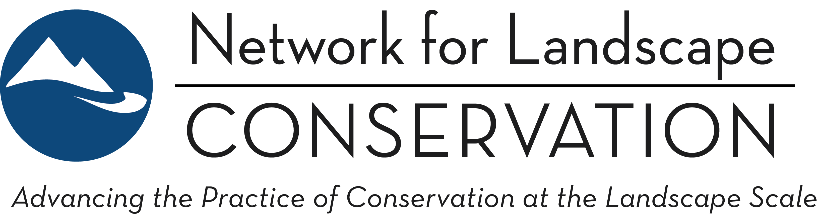

LANDSCAPE CONSERVATION CATALYST FUND
Indigenous-led Partnerships—Priorities and Requirements for 2020 Funding Round

The Network for Landscape Conservation is pleased to invite proposals for the second year of Catalyst Fund grant funding.

A portion of the Catalyst Fund is reserved specifically for Indigenous-led Partnerships that work to advance Indigenous landscape conservation priorities. Key requirements for this portion of the Fund are summarized here. Additional information on the Catalyst Fund can be found in the Request for Proposals (RFP) and the supplemental Applicant Guidance Document.

Catalyst Fund Purpose:
The purpose of the Landscape Conservation Catalyst Fund is to accelerate the pace of conservation at scale through targeted support of collaborative Landscape Conservation Partnerships. The Catalyst Fund specifically supports key collaborative processes and activities to build critical capacity and forward conservation momentum in Landscape Conservation Partnerships.

Priorities:
Any applicant to the Catalyst Fund must meet the first three priorities of the Fund:
- Landscape Conservation Partnership—the Fund supports Partnerships that are place-based; focused on a shared, long-term conservation vision; collaboratively governed; inclusive; and informed;
- The “Building” Stage of Partnership development—the Fund supports Partnerships that are transitioning from collective vision to collective action;
- Capacity Building and the Collaborative Process—the Fund seeks to invest in capacity building and supporting the collaborative processes that strengthen the fabric of the Partnership and accelerates forward conservation momentum.

See RFP and Applicant Guidance Document for more information on the above priorities.

Applicants to the Indigenous-led Partnerships portion of the Fund must meet a fourth priority:
- Indigenous-Led and Primarily Serving Indigenous Communities—The Partnership must be clearly led by Indigenous voices and primarily work to advance Indigenous conservation priorities. This can include Partnerships focused wholly on sovereign tribal lands and/or Partnerships focused on advancing and conserving Indigenous interests, territories, and rights across a broader, defined landscape.
In addition to meeting the above priorities and evaluation criteria spelled out in the RFP, strong proposals from Indigenous-led Partnerships will:
- Emerge from and be supported by the Indigenous community(s)—its purpose, design, and actions will originate from the Indigenous peoples the Partnership serves;
- Promote and respond to leadership and decision-making that directly serve the Indigenous community(s) involved in the Partnership;
- Integrate and support traditional knowledge and cultural lifeways of the community;
- Involve the largest number of people and broadest segments of the Indigenous community(s) as is reasonable; and
- Build capacity in the Indigenous community(s) to advance the conservation goals of the Partnership in the longer term.
Eligibility: U.S. based non-profit organizations with approved IRS 501(c)(3) status are eligible to apply. In the American West (defined to include the following states: Montana, Wyoming, Colorado, New Mexico, Arizona, Utah, Idaho, Nevada, California, Oregon, Washington, and Alaska), Indigenous-led Partnership applicants are also eligible to apply under IRS Code, Section 7871. If a Partnership does not have formal 501(c)(3) or Section 7871 status, another eligible organization may apply on behalf of a Partnership as the fiscal sponsor.

The Network prefers that Indigenous grant monies flow to Indigenous organizations and staff where possible. We also recognize applicants may choose to work with non-indigenous consultants or fiscal sponsors for sound reasons. Just please note that a strong proposal, as outlined above, should help “Build capacity in the Indigenous community(s) to advance the conservation goals of the Partnership in the long term.”

Match Requirement: Indigenous-led applications are not required to provide matching funds, but proposals will be viewed favorably if they can demonstrate, 1) in-kind support from partners (time, meeting space, other); 2) additional direct funding from other sources; and/or 3) a strategy for leveraging a Catalyst Fund grant to attract new funding to the Partnership.

How to Apply: The Catalyst Fund has a two-stage application process, with an open call for pre-proposals followed by invitation-only full proposals. The application process is handled via the Network’s online application system. Pre-proposals for the 2020 funding round are due by 9 pm Eastern time on March 13, 2020.

Applicants that meet Indigenous-led Partnerships requirements should access the online application system and select the Indigenous-led Partnerships application from the main dashboard. If preferred, the Indigenous-led Partnership pre-proposal form can be completed as a Word form and submitted via email to Jonathan Peterson.

More information can be found on the Network’s Catalyst Fund website. All inquiries about the Catalyst Fund and the application process can be directed (via email) to the Catalyst Fund Manager, Jonathan Peterson.

