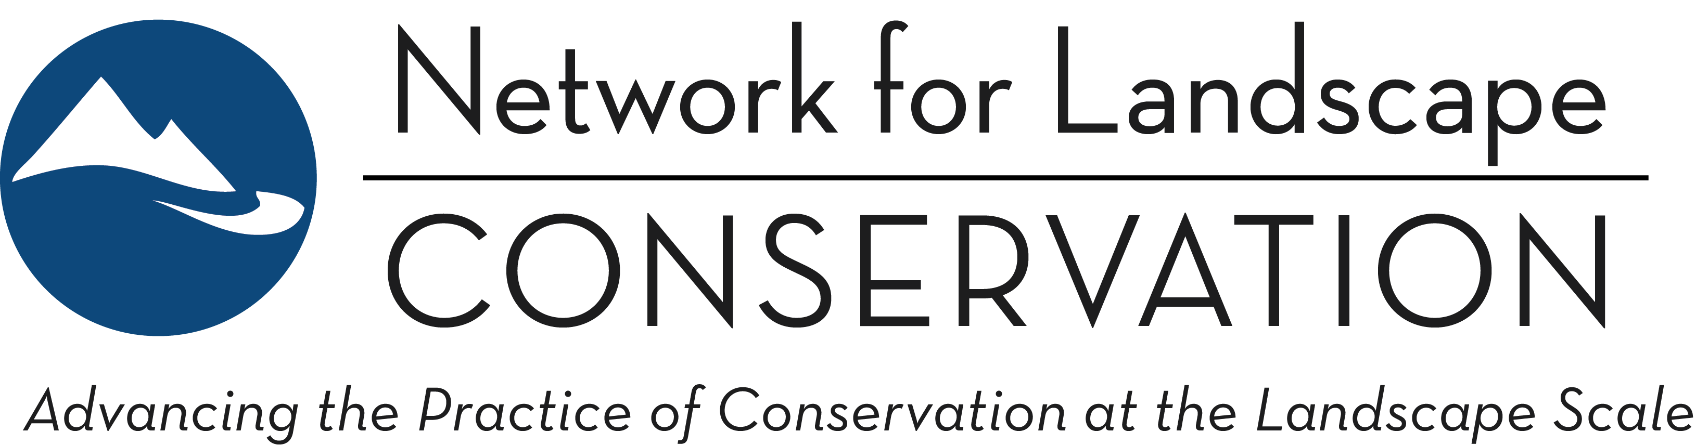

THE LANDSCAPE CONSERVATION CATALYST FUND
2021 Funding Round—Proposal Form
March 2021

Indigenous-led Partnerships may submit a proposal, if preferred, using this Word form application instead of the online application process. All other applicants should submit their application via the online application process.
Once completed, email this Word form to Jonathan Peterson with a subject line of Catalyst Fund Proposal Submission.

ELIGIBILITY SCREEN
Please use this initial section as a self-administered eligibility screen. If you answer “no” to any of these questions, you should not proceed with your application: you will not be a strong fit with the Catalyst Fund and will not receive a grant award.

- The Partnership seeking funding is working within a specific, defined landscape.
Refer here to see what the Catalyst Fund considers to be specific, defined landscapes.
Yes No

- The proposal is for a long-term, enduring Partnership.
A Partnership focused on achieving a specific, short-term project (e.g. to build a trail or complete a land deal) would answer “no” here.
Yes No

- The long-term purpose of the Partnership seeking funding is to actively achieve conservation outcomes and goals within the landscape.
Yes No

- The proposal is structured around investing in the Partnership’s collaborative capacity and collaborative process to better position it long-term to achieve its conservation goals.
Requests for funding support for direct conservation project implementation [e.g. land acquisitions or stewardship costs] would answer “no” here.
Yes No

-- Continue on the next page to complete the proposal --

PROPOSAL
Proposal Title:
Provide a brief, one-sentence title for your proposal.

Proposal Summary:
In one paragraph, succinctly summarize what the funding will enable you to accomplish and the impact that this will have on your Partnership’s ability to achieve its conservation goals within your defined landscape. This may be used in public descriptions of awarded grants.
Requested character limit: 500

Name of Landscape Conservation Partnership:
Website (if available):
Year Launched:

Grant Request: 1 year or 2 year
Grant Request Amount:

Total Budget for Proposed Activities:
Please indicate how much the proposed activities will cost in total, including the grant amount requested and additional direct match funding.
Anticipated approximate budget of your Partnership for 2021:
Please do not provide the annual budget for the applicant organization (if organization is applying on behalf of a Partnership); instead provide an estimate for the budget of the actual Partnership.

SELECTION QUESTIONS
Geography: In which geographic region does this Partnership operate?
Select the region that best fits, recognizing that some partnerships may cross these arbitrary boundaries; more than one region can be selected. View this map if you are unsure which region your landscape is located in.
Northeast: New England
Northeast: Middle Atlantic
South: South Atlantic
South: East South Central
South: West South Central
Midwest: East North Central
Midwest: West North Central
West: Mountain
West: Pacific

Size: Size (in acres) of the Partnership’s landscape?
<500,000
500,000-999,999
1 million-5 million
6 million-10 million
11 million-50 million
51 million-100 million
>100 million

Meeting Frequency: How often does the core group of partners within the Partnership meet?
Monthly
Quarterly
Annually
Less Frequently
Other?
Comment:

Current Staffing: How is the Partnership staffed/coordinated?
A paid full-time (.76 or greater FTE) coordination position is staffed.
A paid part-time (.25-.75 FTE) coordination position is staffed.
A paid limited part-time (less than .25 FTE) coordination position is staffed.
Staff member(s) from partner organizations provide part-time, undedicated coordination support.
Community members or other individuals provide volunteer coordination support.
No coordination support is currently provided.

PROPOSAL NARRATIVE:
As you consider your answers to the following questions, we encourage you to clearly convey how your Partnership reflects the Catalyst Fund's prioritized Partnership characteristics, and how a Catalyst Fund grant award will catalyze your Partnership at a critical point in its development, in ways that change the trajectory of conservation outcomes on your landscape over the long term.
We request that each of the four narrative questions below be addressed in 500 words or fewer. There is a margin of buffer built into the character limits set below, as we don’t believe spending extensive time editing slightly longer responses down to hit precise limits is productive or beneficial. However, your responses to the following four narrative questions should not exceed five pages in length in total.

Question 1: The Why—Tell us why your Landscape Conservation Partnership exists?
Ground us briefly in the geography and context of your landscape—what defines the landscape that you are focused on? We want to understand the shared conservation purpose of your Partnership—what are partners coming together to try to achieve? We will be looking for a clear sense of the mission, goals, and strategies of your Partnership.
Requested character limit: 3500

Question 2: The Who—Introduce us to your Landscape Conservation Partnership.
We encourage you to share the story of who comprises your Partnership and how it operate. We’re less interested in the naming of specific individuals/organizations and more interested in getting a clear sense of the breadth and range of entities and interests that are represented.
The types of questions that may be helpful to consider here include: How often are partners meeting or communicating? How are decisions made? What does the leadership of the Partnership look like? (e.g., is there a lead convening and/or host organization(s)? Is there a core leadership team, such as a steering committee? Are there working groups?) How has your Partnership grown or evolved over time? How do you work to ensure your efforts are community-grounded and centering a diversity of voices, including voices that have been historically marginalized and/or silenced?
(Note: This is not a definitive list of questions to answer one by one but rather is intended to orient you to the direction of our inquiry. Some of the above sample questions may not be relevant to your Partnership.)
Requested character limit: 3500

Question 3: The What—Tell us what you propose to do with Catalyst Fund support.
We want to understand what your Partnership plans to do with a Catalyst Fund grant award: what activities will you undertake to build the collaborative capacity and process of your Partnership? Please share the work plan that grant funding would support, outlining specific Partnership-building activities and the resulting deliverables that you plan to pursue over the course of the grant period.
Requested character limit: 3500

Question 4: The Impact—Tell us how a grant award will accelerate your Landscape Conservation Partnership’s ability to achieve its conservation purpose.
We want to understand how the planned collaborative capacity and process investments will change the trajectory of your Partnership over the long term. How do the activities and deliverables identified above strengthen and accelerate the development of your Partnership? What will be the significance of this accelerated Partnership development on the landscape: How does the Catalyst Fund investment better position your Partnership to achieve its conservation goals over the long term?
Requested character limit: 3500

The Catalyst Fund couples financial support with capacity-building support, and each funded Partnership will be invited to participate in a two-year Peer Learning cohort. Would a representative of your Partnership be able and willing to participate in the Peer Learning program?
Yes No
Comment box:

ATTACHMENTS:
Proposal Budget
Download this proposal budget template, complete, and include as an attachment in your emailed submission.

Map of landscape (if available, not required)
If available, include as an attachment to your email a map or schematic of the Partnership boundary and the associated landscape. Note: If no map is available, this will not influence the evaluation of your proposal. Please do not spend additional time here: only share if you have something available at your fingertips.

Additional materials:
Our expectation is that nothing further will be needed for us to understand your proposal. However, if you feel an additional item (e.g. a strategic or conservation plan, a partners or leadership list, a storymap, etc.) is critical to conveying the story of your Partnership and how a Catalyst Fund grant award will accelerate your conversation efforts—beyond what is already captured in the narrative—you may include it in your emailed submission. Because the evaluation process will primarily focus on your responses to the above narrative questions, we STRONGLY recommend that you only share additional materials if doing so is critical to advancing the concept of your proposal.

