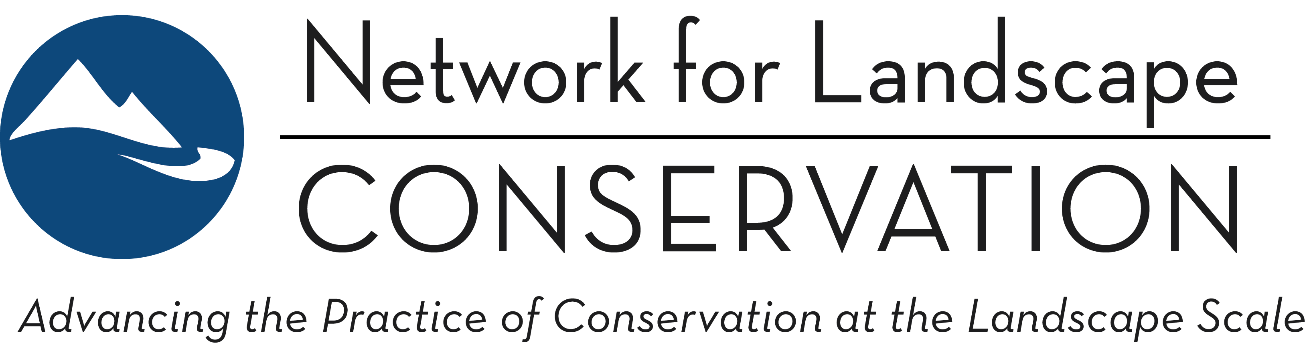

LANDSCAPE CONSERVATION CATALYST FUND
Indigenous-led Partnerships—2020 Pre-Proposal Form

This application is for Indigenous-led Partnerships that serve Indigenous communities working on landscape conservation. If you meet the criteria for Indigenous-led Partnerships (see RFP), you are invited to use this word form application instead of the online application process if you prefer. All other applicants should submit their application via the online application process.

* * *

Is your partnership Indigenous-led and primarily working to advance Indigenous landscape conservation priorities?
(Choices)
Yes
No

SECTION I—APPLICANT ORGANIZATION INFORMATION
Applicant Organization Name:
Mailing Address: Street: City:
State: ZIP:
Organization Tax Identification (EIN): -
Organization must have status under IRS code as a 501(c)3 organization or as a federally recognized tribal government, Section 7871.
Contact:
Phone: - -
E-mail:
Total annual budget (applicant organization):

What is the relationship of the applicant organization to the Landscape Conservation Partnership?
If your Landscape Conservation Partnership is not a registered IRS 501(c)(3) or Tribal 7871 organization and another organization is applying on behalf of the Partnership, clarify the relationship by selecting the best descriptor below (if your Partnership is applying directly because it is an eligible organization, select “Not applicable”):
(Choices)
The applicant is the lead convener of the Partnership.
The applicant is a partner organization within the Partnership.
The applicant is the formal fiscal sponsor organization but otherwise uninvolved in the Partnership.
Not applicable.

SECTION II—PARTNERSHIP INFORMATION
Name of Landscape Conservation Partnership:

Landscape Conservation Partnership Website, if applicable:
Year Partnership Launched:
Number of core partners that are involved in the partnership:

In which geographic region does this Partnership operate?
Select the region that best fits, recognizing that some Partnerships may cross these arbitrary boundaries; more than one region can be selected. Note: regions based on the U.S. Census Bureau Regions and Divisions delineations; if you are unsure of your region under this classification system, please click the above link to access a map that clarifies the delineations.
(Choices)
Northeast: New England
Northeast: Middle Atlantic
South: South Atlantic
South: East South Central
South: West South Central
Midwest: East North Central
Midwest: West North Central
West: Mountain
West: Pacific

Size (in acres) of the Partnership's landscape?*
(Choices)
<500,000
500,000-999,999
1 million-5 million
6 million-10 million
11 million-50 million
51 million-100 million
>100 million

How often does the core group of partners within the Partnership meet?*
(Choices)
Monthly
Quarterly
Annually
Less Frequently

How is the Partnership coordinated/staffed?*
(Choices)
A paid full-time (.76 or greater FTE) coordination position is staffed
A paid part-time (.25-.75 FTE) coordination position is staffed
A paid limited part-time (less than .25 FTE) coordination position is staffed
A paid limited part-time (less than .25 FTE) coordination position is staffed
Staff member(s) from partner organizations provide part-time, undedicated coordination support
Community members or individuals provide volunteer coordination support
No coordination support is currently provided

SECTION III—GRANT REQUEST
We are requesting:
(Choices)
One Year grant
Two Year grant
Total grant amount requested (not to exceed $25,000 over two years):
Total approximate annual budget for your partnership:
This proposal has been endorsed by the collaborative leadership structure of the Partnership.* Note: If invited to submit a full proposal, a letter of endorsement from the Partnership leadership structure will be requested at that point.
(Choices)
Yes
Not yet (Provide further information in the space below)
If "Not yet," provide a brief explanation of the planned approval process. (Character limit: 250):

SECTION IV—PROPOSAL NARRATIVE

- Proposal Title (Character Limit: 100):
- Proposal Purpose—Succinctly summarize what the funding will enable you to accomplish, why this is important, and the catalytic impact that this will have on your Partnership’s ability to achieve its conservation vision. (Character limit: 400):
- Partnership Purpose:
  - Partnership Vision and Mission—Has your Partnership crafted vision and/or mission statements? If so, please provide the statement(s) (or summary of the statement(s) if it exceeds space limits) here. (Character Limit: 750):
  - The vision and mission statement(s) above:
(Choices)
Formally adopted by Partnership leadership;
Universally accepted and used by the Partnership but not formally adopted;

In working draft form.

Vision and/or mission statements not yet in development.

If the statement(s) is not formally adopted, provide a brief explanation of the planned adoption process. (Character limit: 250):
  - Goals—Briefly expand upon the purpose of your Partnership: What are the specific conservation and associated landscape goals that your Partnership is striving to achieve on the ground? (Character Limit: 1000):
- Landscape Significance—Provide a brief summarizing description of the Partnership’s landscape, its conservation value from an ecological and cultural perspective, and the threats this landscape faces that you are working to address. (Character Limit: 1000):
- Partnership Origins and Progress—Briefly describe the origins of your Partnership: why was it formed, who led the process, and when? Outline the partnership-building activities that have been accomplished to date. Note here how knowledge sources such as traditional knowledge or Western science are being used to inform your work. (Character Limit: 1000):
- Partnership Structure—Briefly describe how the Partnerships functions: who is in your partnership (one or many tribes? State or Federal agencies? Other NGOs) and how do you make decisions? Do you have a leadership or governance structure in place? If so, briefly describe. Who do you plan to include going forward? Be clear on the role of Indigenous people and Indigenous perspectives in the Partnership. (Character Limit: 1000):
- Proposed Activities and Grant Period Impact—Outline the specific partnership-building activities that you would like funding to support. What outcomes do you hope to achieve through these activities by the end of the grant period? (Character Limit: 1500):
- Longer-term Impact—What is the impact of this grant for your Partnership in the long term (past the grant period)? How will this current grant work strengthen the fabric of your Partnership and contribute to successfully achieving your Partnership’s conservation vision for the landscape in the longer term? Distinguish between grant period outcomes (previous question) and longer-term impact: how will this grant be catalytic in the longer term? (Character Limit: 750):

SECTION V—ATTACHMENTS

Please include the following as attachments:
- 501(c)(3) IRS Determination Letter OR Tribal 7871 Determination Letter
- Map of Partnership area
If you have one, share a map or schematic of the landscape in which the Partnership operates. Note: this is optional and will not influence the evaluation of your pre-proposal.
- Complete Budget Template on next page.

Once completed, this pre-proposal form should be emailed to the Catalyst Fund Manager at jonathan@landscapeconservation.org by 9 pm Eastern Time on Friday, March 13, 2020.

Landscape Conservation Catalyst Fund
Pre-Proposal Preliminary Budget
Name of Landscape Conservation Partnership:
Instructions: Use this template to identify how the requested grant monies will be spent. If requesting a two-year grant, show the amounts spent in each year. Use the appropriate columns to capture how any anticipated direct cash match and in-kind match will be utilized in achieving the proposed activities. Direct cash match would include additional grant monies or funding from partner organizations; in-kind match would include donated partner staff time and donated goods and services.
For personnel costs, please list each individual and/or position separately. Add additional lines if needed. Direct costs should include for instance, convening [space, food, lodging, and travel]; web and print communications; outreach activities that educate and involve stakeholders, and costs involved in science-informed landscape conservation planning, mapping, and prioritization. Specific direct costs should be listed individually; add additional lines as needed.
Please use the boxes beneath the budget to indicate the source and status of any anticipated direct match funding.
Note: budget numbers can be preliminary at this stage.
 | Catalyst Fund Funding |  | Match Funding*
 | Year 1 | (Year 2) | Anticipated Direct Funding | Anticipated In-Kind | Notes: (optional)  Please limit each note to one line or less
Personnel (Staff and Consultants)
List each individual/position separately
a.
b.
c.
Other Direct Costs
a.
b.
c.
d.
e.
f.
Indirect Costs (i.e. overhead; no more than 12% of total)
Total | $ | $ | $ | $
Total Grant Request: | $
*Please list the source of your anticipated direct match funding (adding more lines as needed):
Additional Funding Source | Amount | Status | (for status, indicate secured, likely, or unknown)

