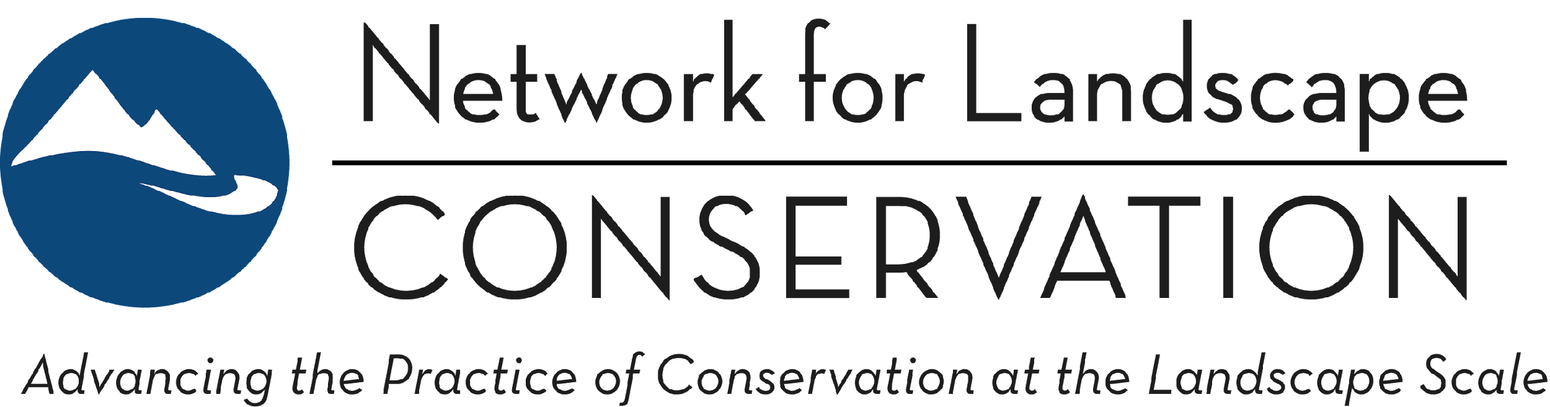

Job Announcement: Program Associate
November 2023

Position Type: Full time, exempt
Location: Fully remote; must be eligible to work in the United States
Compensation: $52,000-$55,000
Benefits: Fully paid medical & dental insurance, up to a 5% match on 401k contributions, generous PTO, and flexible scheduling
Application Deadline: Review of applications will begin on December 1, 2023
Targeted Start Date: January 2024

* * * *

About the Network: Launched in 2011, the Network for Landscape Conservation’s mission is to advance collaborative, community-grounded conservation at the landscape scale as an essential approach to connect and protect nature, culture, and community. For more background, visit our website: www.landscapeconservation.org. The Network functions as the national umbrella group and leading voice for the collaborative landscape conservation and stewardship movement, working to connect people to ideas and innovations—and to each other—in order to accelerate the pace and practice of this critical work.
The Network and the broader landscape community is at an inflection point; as the importance of collaborative landscape approaches becomes ever clearer, the Network seeks to expand its staff capacity with the hiring of a new position to support core operations, including the Catalyst Fund. This position will play a significant role in supporting the continued evolution of the Network, and is intended to capitalize on the energy and impact of the Catalyst Fund to build, strengthen, and support a network of place-based, community-grounded landscape collaboratives that can function as the essential vehicles for delivering locally-led, nationally-scaled conservation and stewardship outcomes.

Position Overview: The Program Associate will provide critical day-to-day support in the execution of core Network activities including the Catalyst Fund, providing support to and working closely with the Network Director and Network leadership to ensure the effective and efficient operation of the Network. Given the dynamic nature of networks, the Program Associate will also have space to explore and grow in areas of particular interest related to developing and supporting a connected, informed landscape community of practice.

Essential Duties: The Program Associate will be responsible for:
- Implementing the Network’s external communications and information-sharing activities, including:
  - Preparing and distributing the bi-monthly Landscape Conservation Bulletin, including coordinating logistics for the periodic “Perspectives” guest column feature;
  - Coordinating the Network’s “Landscape Conservation in Action” webinar series;
  - Maintaining the content of the Network’s website;
- Supporting internal communications and information flow within the Network, including:
  - Providing general logistical and backbone support to Network leadership and working groups;
- Providing systems support and coordination for the implementation of the Catalyst Fund, including:
  - Coordinating the mechanics for the grant review and grant award processes, including utilization of our online grant management system;
  - Coordinating communications with interested applicants throughout the grant application process, and with grantees following grant award;
  - Providing logistical support to the Catalyst Fund Peer Learning programs following grant awards;
- Providing logistics and planning support for retreats (Network leadership and Catalyst Fund) as well as any additional convenings that the Network advances;
- Carrying forward specific projects and/or additional activities that may emerge as Network conversations advance.

Skills and Qualifications: The Network for Landscape Conservation is seeking an individual who is passionate about collaborative landscape conservation and stewardship as a means for advancing just, equitable, and sustainable futures for people and places. We seek applicants that enjoy being part of a small, nimble staff team and that find energy in the emergent aspects of networks. Indeed, networked spaces are fast-paced, dynamic environments; we seek applicants that can enter into such a space with curiosity and compassion, and that can navigate with grace, humility, and good humor. Specifically, a successful applicant for the Program Associate role will possess:
- Strong attention to detail, strong project management skills, and the ability to multitask;
- Clear and effective verbal and written communication skills;
- Demonstrated collaborative leadership skills and experience building and stewarding strong relationships and connections with partners and colleagues within a field of practice;
- Experience in and knowledge of the practice of collaborative landscape conservation and stewardship;
- Proficiency with standard office technology and tools, including G-Suites, email marketing, video conferencing, and presentation platforms; more advanced familiarity and experience with WordPress, Constant Contact, Adobe Creative Suite, and grantmaking management software is a plus.

Reporting Structure: This position will report to the Network Director. Given that the Network is a fiscally sponsored project, the position will officially be an employee of the Network’s fiscal sponsor, the Center for Large Landscape Conservation (see below).

Location and Travel: This is a fully remote position, as the Network does not maintain dedicated office space. Employee will be expected to maintain high-functioning internet (sufficient for video conferencing) and phone access to work efficiently and effectively in a virtual spaces. Periodic travel (within the United States) may be required.

Compensation: This is a full time exempt position with a wage range of $52,000-$55,000 annually. Exemplary candidates with schedule constraints will still be considered (as long as it remains a minimum of .75 FTE or 30 hours/week), compensation pro rata. Benefits include generous paid time off, 100% coverage for medical & dental insurance for employee, up to 5% match on a 401k after 6 months of service, and flexible scheduling.

Application Process and Timeline: Interested candidates are invited to submit a letter of interest (no more than two pages) and a resume capturing relevant experience to jonathan@landscapeconservation.org. Review of applicants will begin on December 1st, and the position will remain open until filled. We anticipate contacting exemplary candidates for one round of interviews (to be conducted via Zoom or Phone) beginning in early to mid-December. Our ideal start date will be early to mid-January, 2024, but is negotiable.

About our Fiscal Sponsor: The Network for Landscape Conservation is fiscally sponsored by the Center for Large Landscape Conservation (CLLC). Headquartered in Bozeman, Montana, CLLC’s mission is to protect life on Earth by promoting ecological connectivity to support healthy wildlife habitats and safeguard nature’s resilience to climate change. To advance this mission, CLLC supports a range of networks, including NLC, that are increasing connectivity with people and landscapes. CLLC works to actively cultivate an inclusive workplace and to value the leadership, skills, and perspectives of people from diverse backgrounds. People of color, LGBTQ+ persons, and people from other historically marginalized communities are strongly encouraged to apply.

The Center for Large Landscape Conservation is an equal opportunity employer. Employment decisions are made without regard to sex, race, color, age, national origin, religion, disability, marital status, sexual orientation, gender identity/expression, citizenship, pregnancy or maternity, veteran status, or any other status protected by applicable national, federal, state or local law.

